Software Design
for

Campus Management Application
at
World Skill Center (WSC)

Design Feature - Students Management Module



Sustainable Outreach And Universal Leadership (SOUL) Limited
Version no 0.1
VERSION HISTORY
Date | Version No. | Created By | Updated Section | Updated By
14-03-2023 | Version 0.1 | Nehal Kumar

Contents
1. Introduction 8
2. LITERATURE REVIEW 9
3. Platform Overview 9
3.1 Platform requirements 9
3.1.1 Software Stack 9
3.2.2 Hosting requirement 10
4. Architecture 10
5. Organization Structure: 11
6. Design Overview: 11
6.1 Exam Type 11
6.1.1 Overview 11
6.1.2 Description of Problem 11
6.1.3 A Table of Contents 12
6.1.4 Use Case 12
6.1.5 Form Elaboration 12
6.1.6 Screen Authorization 12
6.1.7 Component And Module 13
6.1.8 Business Logic 13
6.1.9 Path of the screen 13
6.2 Assessment Criteria 13
6.2.1 Overview 13
6.2.2 Description of Problem 13
6.2.3 Dependency 13
6.2.4 A Table of Contents 13
6.2.5 Use Case 13
6.2.6 Form Elaboration 14
6.2.7 Component And Module 14
6.2.8 Screen Authorization 14
6.2.9 Business Logic 15
6.2.10 Path of the screen 15
6.3 Grading Scale 15
6.3.1 Overview 15
6.3.2 Description of Problem 15
6.3.3 Dependency 15
6.3.4 Table of Contents 15
6.3.5 Use Case 15
6.3.6 Form Elaboration 16
6.3.7 Screen Authorization 16
6.3.8 Component And Module 16
6.3.9 Business Logic 17
6.3.10 Path of the screen 17
6.4 Student Exam Block Criteria 17
6.4.1 Overview 17
6.4.2 Description of Problem 17
6.4.3 Table of Contents 17
6.4.4 Use Case 17
6.4.5 Form Elaboration 18
6.4.6 Screen Authorization 18
6.4.7 Component And Module 18
6.4.9 Business Logic 18
6.4.10 Path of the screen 18
6.5 Exam Declaration 18
6.5.1 Overview 18
6.5.2 Description of Problem 18
6.5.3 Dependency 18
6.5.4 Table of Contents 19
6.5.5 Flow Chart 19
6.5.6 Use Case 19
6.5.7 Form Elaboration 20
6.5.8 Screen Authorization 21
6.5.9 Component And Module 21
6.5.9 Business Logic 21
6.5.10 Path of the screen 22
6.6 Exam Application 22
6.6.1 Overview 22
6.6.2 Description of Problem 22
6.6.3 Dependency 22
6.6.4 Table of Contents 22
6.6.5 Form Elaboration 22
6.6.6 Use Case 23
6.6.7 Component And Module 23
6.6.8 Screen Authorization 23
6.6.9 Business Logic 24
6.6.10 Path of the screen 24
6.7 Exam Paper Setting 24
6.7.1 Overview 24
6.7.2 Description of Problem 24
6.7.3 Dependency 24
6.7.4 Table of Contents 24
6.7.5 Use Case 25
6.7.6 Form Elaboration 25
6.7.7 Screen Authorization 26
6.7.8 Component And Module 26
6.7.9 Business Logic 26
6.7.10 Path of the screen 26
6.8 Exam Block List 26
6.8.1 Overview 26
6.8.2 Description of Problem 27
6.8.3 Dependency 27
6.8.4 Table of Contents 27
6.8.5 Use Case 27
6.8.6 Form Elaboration 28
6.8.7 Screen Authorization 28
6.8.8 Component And Module 28
6.8.9 Business Logic 28
6.8.10 Path of the screen 28
6.9 Student Admit Card 28
6.9.1 Overview 28
6.9.2 Description of Problem 29
6.9.3 Dependency 29
6.9.4 Table of Contents 29
6.9.5 Use Case Diagram 29
6.9.6 Form Elaboration 29
6.9.7 Screen Authorization 30
6.9.8 Component And Module 30
6.9.9 Business Logic 30
6.9.10 Path of the screen 30
6.10 Post Exam Declaration 30
6.10.1 Overview 31
6.10.2 Description of Problem 31
6.10.3 Dependency 31
6.10.4 A Table of Contents 31
6.10.5 Use Case Diagram 31
6.10.6 Form Elaboration 31
6.10.7 Screen Authorization 32
6.10.8 Component And Module 32
6.10.9 Business Logic 32
6.10.10 Path of the screen 32
6.11 Photocopy Application 32
6.11.1 Overview 32
6.11.2 Description of Problem 33
6.11.3 Dependency 33
6.11.4 A Table of Contents 33
6.11.5 Use Case Diagram 33
6.11.6 Form Elaboration 34
6.11.7 Screen Authorization 34
6.11.8 Component And Module 34
6.11.9 Business Logic 34
6.11.10 Path of the screen 34
6.12. Exam Evaluation Plan 34
6.12.1 Overview 34
6.12.2 Description of Problem 34
6.12.3 Dependency 35
6.12.4 Table of Contents 35
6.12.5 Use Case Diagram 35
6.12.6 Form Elaboration 35
6.12.7 Screen Authorization 36
6.12.8 Component And Module 36
6.12.9 Business Logic 36
6.12.10 Path of the screen 36
6.13. Criteria Wise Evaluation 36
6.13.1 Overview 36
6.13.2 Description of Problem 36
6.13.3 Dependency 37
6.13.4 Table of Contents 37
6.13.5 Use Case Diagram 37
6.13.6 Form Elaboration 37
6.13.7 Screen Authorization 38
6.13.8 Component And Module 38
6.13.9 Business Logic 38
6.13.10 Path of the screen 38
6.14. Continuous Evaluation 39
6.14.1 Overview 39
6.14.2 Description of Problem 39
6.14.3 Dependency 39
6.14.4 Table of Contents 39
6.14.5 Use Case Diagram 39
6.14.6 Form Elaboration 40
6.14.7 Screen Authorization 41
6.14.8 Component And Module 41
6.14.9 Business Logic 41
6.14.10 Path of the screen 41
6.15. Final Exam Result 41
6.15.1 Overview 41
6.15.2 Description of Problem 41
6.15.3 Dependency 41
6.15.4 Table of Contents 42
6.15.5 Use Case Diagram 42
6.15.6 Form Elaboration 42
6.15.7 Screen Authorization 43
6.15.8 Component And Module 43
6.15.9 Business Logic 43
6.15.10 Path of the screen 44
6.16 Criteria Wise Evaluation Tool 44
6.16.1 Overview 44
6.16.2 Description of Problem 44
6.16.3 Dependency 44
6.16.4 Table of Contents 44
6.16.5 Use Case Diagram 44
6.16.6 Form Elaboration 45
6.16.7 Screen Authorization 45
6.16.8 Component And Module 46
6.16.9 Business Logic 46
6.16.10 Path of the screen 46
6.17 Continuous Evaluation Tool 46
6.17.1 Overview 46
6.17.2 Description of Problem 46
6.17.3 Dependency 46
6.17.4 Table of Contents 47
6.17.5 Use Case Diagram 47
6.17.6 Form Elaboration 47
6.17.7 Screen Authorization 47
6.17.8 Component And Module 48
6.17.9 Business Logic 48
6.17.10 Path of the screen 48
6.18 Final Result Declaration 48
6.18.1 Overview 48
6.18.2 Description of Problem 48
6.18.3 Dependency 48
6.18.4 Table of Contents 48
6.18.5 Use Case Diagram 48
6.18.6 Form Elaboration 49
6.18.7 Screen Authorization 49
6.18.8 Component And Module 50
6.18.9 Business Logic 50
6.18.10 Path of the screen 50
6.19 Cumulative Marksheet Tool 50
6.19.1 Overview 50
6.19.2 Description of Problem 50
6.19.3 Dependency 50
6.19.4 Table of Contents 50
6.19.5 Use Case Diagram 51
6.19.6 Form Elaboration 51
6.19.7 Screen Authorization 52
6.19.8 Component And Module 52
6.19.9 Business Logic 52
6.19.10 Path of the screen 52
6.20 Provisional Certificate Tool 52
6.20.1 Overview 52
6.20.2 Description of Problem 52
6.20.3 Dependency 52
6.20.4 Table of Contents 52
6.20.5 Use Case Diagram 53
6.20.6 Form Elaboration 53
6.20.7 Screen Authorization 53
6.20.8 Component And Module 53
6.20.9 Business Logic 54
6.20.10 Path of the screen 54
6.21 Migration Certificate Tool 54
6.21.1 Overview 54
6.21.2 Description of Problem 54
6.21.3 Dependency 54
6.21.4 Use Case Diagram 54
6.21.5 Table of Contents 55
6.21.6 Form Elaboration 55
6.21.7 Screen Authorization 55
6.21.8 Components And Modules 56
6.21.9 Business Logic 56
6.21.10 Path of the screen 56
6.22 Conduct Certificate Tool 56
6.22.1 Overview 56
6.22.2 Description of Problem 56
6.22.3 Dependency 56
6.22.4 Use Case Diagram 56
6.22.6 Form Elaboration 57
6.22.7 Screen Authorization 57
6.22.8 Components And Modules 58
6.22.9 Business Logic 58
6.22.10 Path of the screen 58
6.23 Leaving Certificate 58
6.23.1 Overview 58
6.23.2 Description of Problem 58
6.23.3 Dependency 58
6.23.4 Use Case Diagram 58
6.23.6 Form Elaboration 59
6.23.7 Screen Authorization 60
6.23.8 Components And Modules 60
6.23.9 Business Logic 60
6.23.10 Path of the screen 60
6.24 Provisional Certificate 60
6.24.1 Overview 60
6.24.2 Description of Problem 60
6.24.3 Dependency 61
6.24.4 Use Case Diagram 61
6.24.6 Form Elaboration 61
6.24.7 Screen Authorization 61
6.24.8 Components And Modules 62
6.24.9 Business Logic 62
6.24.10 Path of the screen 62
6.25 Migration Certificate 62
6.25.1 Overview 62
6.25.2 Description of Problem 62
6.25.3 Dependency 62
6.25.4 Use Case Diagram 62
6.25.6 Form Elaboration 63
6.25.7 Screen Authorization 63
6.25.8 Components And Modules 63
6.25.9 Business Logic 64
6.25.10 Path of the screen 64
6.26 Conduct Certificate 64
6.26.1 Overview 64
6.26.2 Description of Problem 64
6.26.3 Dependency 64
6.26.4 Use Case Diagram 64
6.26.6 Form Elaboration 65
6.26.7 Screen Authorization 65
6.26.8 Components And Modules 66
6.26.9 Business Logic 66
6.26.10 Path of the screen 66
6.27 Cumulative Marksheet 66
6.27.1 Overview 66
6.27.2 Description of Problem 66
6.27.3 Dependency 66
6.27.4 Use Case Diagram 66
6.27.6 Form Elaboration 67
6.27.7 Screen Authorization 68
6.27.8 Components And Modules 68
6.27.9 Business Logic 68
6.27.10 Path of the screen 68

- Introduction

Campus management project for WSC aims at providing an efficient, secure, and user-friendly platform to manage and automate the various processes. It is an integrated system that provides all the necessary tools to manage the various aspects of running a University. This web-based solution enables administrators and faculty to easily track and manage activities related to student registration and enrollment, faculty and staff management, financial management, facility management, and more. Additionally, it also provides features such as reporting and analytics, notification to students and parents using emails.
Scope of project:
- Students Management Modules
- Academic System
- Procurement & Inventory Management
- Human Resources Management System
- Finance and Accounting System
- Training and Placement
- Infrastructure

- LITERATURE REVIEW
The following section first explains the evolution of ERP system and some of its characteristics. It also explores the various modules available in an ERP software. Knowledge-intensive nature of ERP systems and ERP system adoption is also analyzed. Finally it looks into critical success factors for ERP system implementation as well as benefits of ERP implementation.

- Platform Overview

3.1 Platform requirements

3.1.1 Software Stack
Our application use Frappe framework as the major software stack which is an open-source full stack web framework written in Python and JavaScript that is used to develop and maintain web applications. It is designed to be simple, easy to use, and fast. It is built on top of the popular Django web framework. Frappe provides a powerful set of tools for building web applications with a focus on scalability and extensibility. It provides a powerful ORM, a powerful templating system, and a comprehensive set of APIs for building web applications. Frappe is also designed for ease of use, with a focus on reducing development time and building an intuitive admin interface. It also features a seamless integration with other open-source projects such as Redis, MongoDB, and MySQL, as well as a host of APIs and other tools.

3.2.2 Hosting requirement
Our application requires a Linux-based hosting environment. It requires at least 1GB of RAM, 2GB of disk space, and preferably an Ubuntu 16.04 or higher operating system. It also requires a web server such as Apache or Nginx, MariaDB 10.1 or higher, and Python 2.7.x or higher. Additionally, it requires an SMTP server to send emails and an SSL certificate to enable HTTPS.

- Architecture
Our application is based on a web-based, modular, service-oriented architecture (SOA), which allows for the development of custom applications and services that can be integrated with the core Our application platform. It is built on a combination of JavaScript, Python, and MySQL. The architecture of Our application consists of multiple layers, each with its own set of functions and services. At the highest level are the user interface, user experience, and application logic components. These components provide the user with an interface to the Our application system and the ability to interact with the underlying data and services. Below the user interface layer is the data layer, which is responsible for managing the storage and retrieval of data and services. This layer is powered by a combination of MySQL and PostgreSQL databases. The data layer is also responsible for providing secure access to the data and services. The application layer is responsible for providing access to the data and services, as well as providing the business logic that drives the system. The application layer is powered by a combination of Python and JavaScript, and is responsible for providing the core capabilities of the system, such as authentication, authorization, reporting, and analytics. Finally, the service layer is the layer that connects the application layer to the user interface layer. It provides the ability to integrate the Our application system with external systems and services, such as third-party APIs and web services. The service layer is powered by a combination of web services and web sockets. Following is a diagram showing a representation of the architecture of our application:

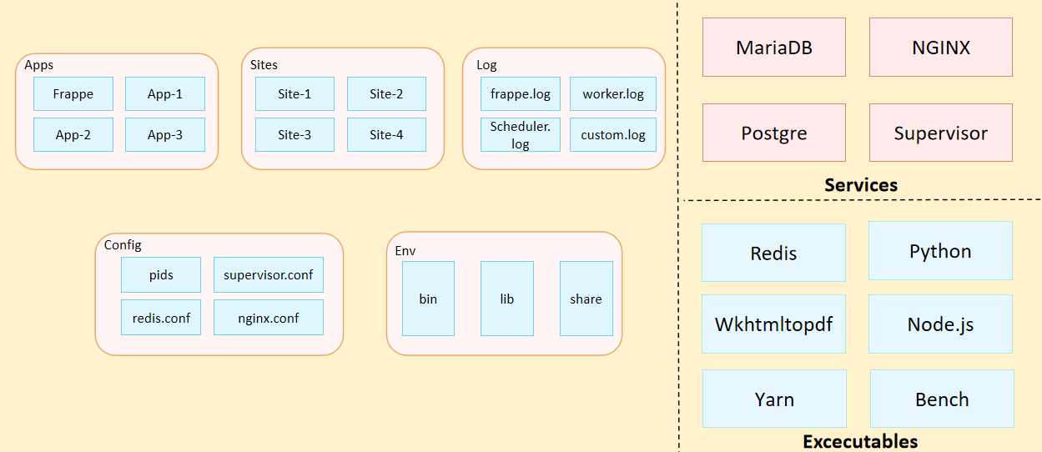
Fig: Architecture of Our Application

- Organization Structure:
Input required form WSC

- Design Overview:

6.1 Exam Type
    - Overview
The Exam Type allows you to create and set values for a particular Exam Declaration which shall be beneficial to determine the type of examinations that are being conductedandcanbe evaluated on the basis of it.
    - Description of Problem
Create a page containing all Information about exam type in the system.
    - A Table of Contents
- Main Table:- TabExam Type
    - Use Case

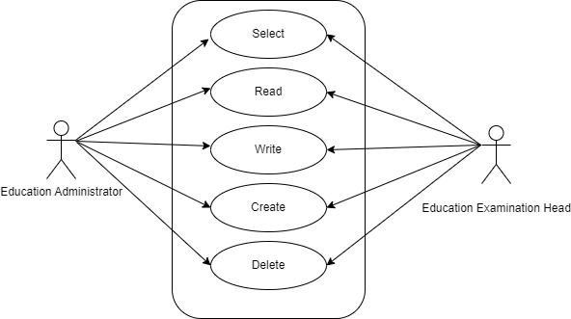

    - Form Elaboration
SL No | Label | Type | Mandatory
1 | Type | Data | 0
2 | Description | Small Text | 0

    - Screen Authorization
Sl No. | Role | Level | Select | Read | Write | Create | Delete | Submit
1 | Education Administrator | 0 | 1 | 1 | 1 | 1 | 1 | 0
2 | Education Examination Head | 0 | 1 | 1 | 1 | 1 | 1 | 0

    - Component And Module
Module Related:- Education

    - Business Logic
- Go to the Exam Type list, click on New.
- Enter Type.
- Enter Description(optional).
- Save

    - Path of the screen
Home > Examination > Examination Master > Exam Type

  - Assessment Criteria
    - Overview
The Assessment Criteria various components of Continuous Evaluation on thebasis ofwhichEvaluation shall be conducted.
    - Description of Problem
Create a page containing all Information about specified as Mid Term, Practical, End Term, Quiz, Viva, etc.
    - Dependency
Before creating a Assessment Criteria, it is advisable you to create the following documents:
Assessment Criteria Group.
    - A Table of Contents
- Main Table- TabAssessment Criteria
    - Use Case
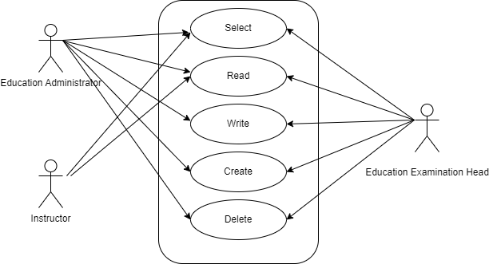

    - Form Elaboration
SL No | Fields | Data Type | Mandatory
1 | Assessment Criteria | Data | 1
2 | Assessment Criteria Group | Link | 0
3 | Maximum Credit | Float | 0
4 | Depends on Exam Declaration | Check | 0

    - Component And Module
Module Related:- Education.
    - Screen Authorization
Sl No. | Role | Level | Select | Read | Write | Create | Delete | Submit
1 | Education Administrator | 0 | 1 | 1 | 1 | 1 | 1 | 0
2 | Education Examination Head | 0 | 1 | 1 | 1 | 1 | 1 | 0
3 | Instructor | 0 | 1 | 1 | 0 | 0 | 0 | 0

    - Business Logic
- Go to the Assessment Criteria list, click on New.
- Enter Assessment Criteria.
- Enter Assessment Criteria Group,Maximum Credit(optional).
- Check Depends on Exam Declaration(optional).
- Save

    - Path of the screen
Home > Examination > Examination Master > Assessment Criteria

  - Grading Scale
    - Overview
Under Grading Scale, you can define the threshold for the different grades obtained by the students, based on their scores in the assessment.
    - Description of Problem
Create a page containing all Information about a Grading Scale Name and Intervals in the system including Grade Code, Grade point, Threshold and Result.

    - Dependency
`No Dependency
    - Table of Contents
- Main Table- TabGrading Scale
- Child Table- TabGrading Scale Interval
    - Use Case

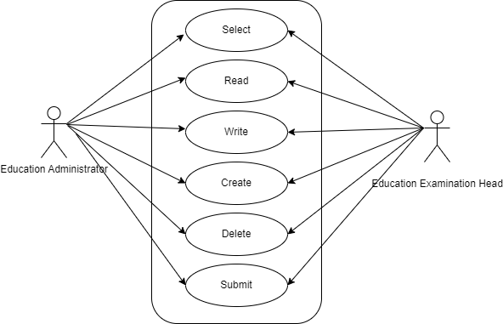

    - Form Elaboration
Sl No | Field Name | Type | Mandatory
1 | Grading Scale Name | Data | 1
2 | Intervals | Table | 1
3 | Amended From | Link | 0
4 | Description | Small Text | 0

    - Screen Authorization
Sl No. | Role | Level | Select | Read | Write | Create | Delete | Submit
1 | Education Administrator | 0 | 1 | 1 | 1 | 1 | 1 | 1
2 | Education Examination Head | 0 | 1 | 1 | 1 | 1 | 1 | 1

    - Component And Module
Module Related:- Education

6.3.9 Business Logic

- Go to the Grading Scale and click on New.
- Enter the Grading Scale Name and Intervals Child Table.
- Save and Submit

6.3.10 Path of the screen
Home > Examination > Examination Master > Grading Scale

  - Student Exam Block Criteria
    - Overview
The Student Exam Block Criteria is used to create various criteria based on which students are blocked from applying for an exam declaration.
    - Description of Problem
Create a page containing all Information about criteria name.

    - Table of Contents
- Main Table- TabStudent Exam Block Criteria

    - Use Case
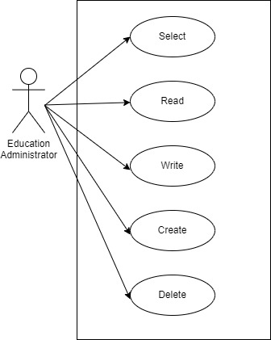

    - Form Elaboration
Sl No. | Field name | Mandatory | Type
1 | Criteria Name | 1 | Data

    - Screen Authorization
Sl No. | Role | Level | Select | Read | Write | Create | Delete | Submit
1 | Education Administrator | 0 | 1 | 1 | 1 | 1 | 1 | 0

    - Component And Module
Module: - Education Module

6.4.9 Business Logic
- Go to Student Exam Block Criteria List and click on New.
- Enter the Criteria Name.
- Save.

6.4.10 Path of the screen
Home > Examination > Examination Master > Student Exam Block Criteria

  - Exam Declaration
    - Overview
The Exam Declaration will allow you to declare an exam for various programs with accordance to the Academic Calendar template which was used during the start of each session.
    - Description of Problem
Create a page containing all Information about a Examination like Exam Type, Exam name, Program, Semester, Course etc.

    - Dependency
Before creating a Exam Declaration, it is advisable you to create the following documents:
- Academic Year
- Academic Term
- Program Grade
- Exam Program
- Semester
- Course

    - Table of Contents
- Main Table:- TabExam Declaration
- Child Table:-
- TabExamination Semester
- TabExam Courses
- TabStudent
- TabExam Declaration Fee Item

    - Flow Chart
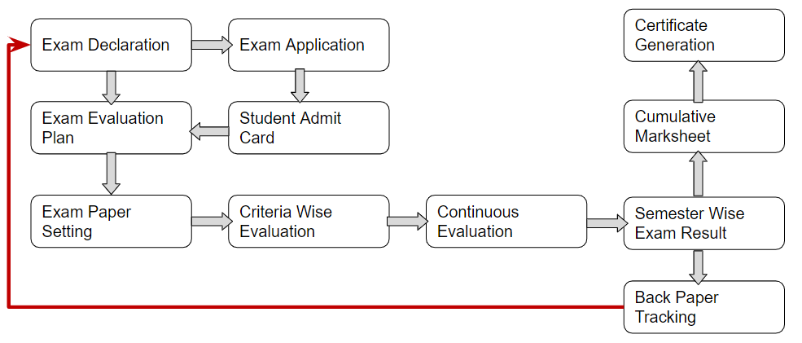
    - Use Case
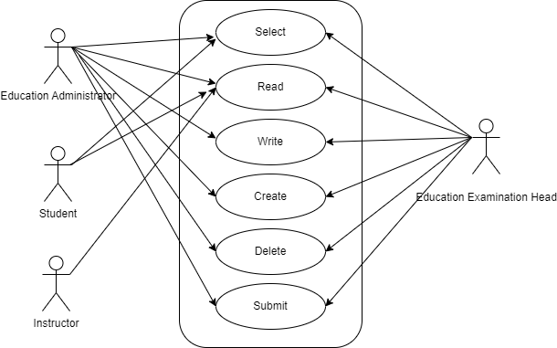
    - Form Elaboration
Sl No | Field Name | Type | Mandatory
1 | Exam Type | Link
2 | Exam Name | Data | 1
3 | Disabled | Check
4 | Is Application Required | Check
5 | Academic Year | Link | 1
6 | Academic Term | Link | 1
7 | Exam Category | Select
8 | Application Form Start Date | Date
9 | Application Form End Date | Date
10 | Exam Start Date | Date | 1
11 | Exam End Date | Date | 1
12 | Admit Card Issue Date | Date
13 | Block List Display Date | Date
14 | Program Grade | Link | 1
15 | Exam Program | Link | 1
16 | Semesters | Table | 1
17 | Get Courses | Button
18 | Courses Offered | Table | 1
19 | Minimum Attendance Criteria | Float | 1
20 | Get Students | Button
21 | Total Enrolled Student | Int
22 | Students | Table
23 | Fees Status | Select | 1
24 | Exam Fees Applicable | Select
25 | Fee Structure | Table

    - Screen Authorization
Sl No. | Role | Level | Select | Read | Write | Create | Delete | Submit
1 | Education Administrator | 0 | 1 | 1 | 1 | 1 | 1 | 1
2 | Education Examination Head | 0 | 1 | 1 | 1 | 1 | 1 | 1
3 | Student | 0 | 1 | 1 | 0 | 0 | 0 | 0
4 | Instructor | 0 | 0 | 1 | 0 | 0 | 0 | 0

    - Component And Module
Module: - Education Module

6.5.9 Business Logic
- Go to Exam declaration and click on New.
- Enter the Exam Type, Exam Name, Academic Year, AcademicTerm.
- If Exam Application is required then mark the checkbox: Enter Application Form Start Date, Application Form End Date
- Select and add the Exam Start Date.
- Select and add the Exam End Date.
- Select and add the Block List Display Date.
- Select and add the Admit Card Issue Date.
- Select and add the Exam Program.
- Semesters related to the selected Exam Program will be displayed on the drop-downlist.
- Select Get Courses.
- Courses Offered Table:
  - Courses from the semesters selected are auto populated in the table.
  - Select and the Examination Date
  - Change the “From Time” and “To Time” to your desirable schedule.
  - Total duration (in Hours) will be auto generated. Select and enter the eligibility details:
- Select and enter the eligibility details:
  - Select and add Minimum Attendance Criteria
  - Select the Fee Status from the list of drop-down options
- Select and add Exam Fees:
  - Select and add Exam Fees if applicable-If Yes, then select and add various fee structures along with due date in the fee structure table according to Student Category.
- Save and Submit

6.5.10 Path of the screen
Home > Examination > Examination > Exam Declaration
  - Exam Application
    - Overview
The Exam Application will allow you to apply for an exam that has been declared for a particular program with accordance to the ‘Academic Calendar’ template which was used during the start of each session.
    - Description of Problem
Create a page containing all Information about which student applied or eligible for exam.
    - Dependency
Before creating a Exam Application, it is advisable you to create the following documents:
- Student
- Exam Declaration
    - Table of Contents
- Main table: TabExam Application
- Child table: TabExam Application Courses

    - Form Elaboration
Sl No | Field Name | Type | Mandatory
1 | Application Date | Date | 0
2 | Student | Link | 1
3 | Application Status | Select | 0
4 | Student Name | Data | 0
5 | Roll No | Data | 0
6 | Registration Number | Data | 0
7 | Exam Declaration | Link | 1
8 | Program Academic Year | Link | 0
9 | Academic Term | Link | 0
10 | Exam Fee | Currency | 0
11 | Current Program | Link | 0
12 | Exam Application Courses | Table | 0

    - Use Case
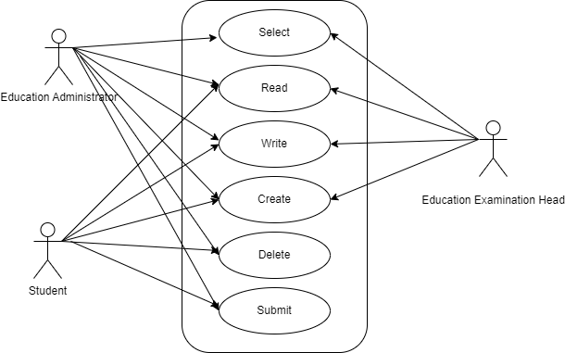
    - Component And Module
Module Related:- Education

    - Screen Authorization
Sl No. | Role | Level | Select | Read | Write | Create | Delete | Submit
1 | Education Administrator | 0 | 1 | 1 | 1 | 1 | 1 | 1
2 | Education Examination Head | 0 | 1 | 1 | 1 | 1 | 0 | 0
3 | Student | 0 | 0 | 1 | 1 | 1 | 1 | 1

    - Business Logic
- Go to the Exam Application list and click on New.
- The current date is auto fixed and cannot be changed.
- Select and Add Student
- Student Name automatically is reflected in the below field.
- Select and Add the Exam Declaration for which is the student is applying.
- Data is auto fetched for:
  - Program Academic Year
  - Academic term
  - Exam Fees
- Save and Submit

    - Path of the screen
Home > Examination > Examination > Exam Application
  - Exam Paper Setting
    - Overview
The Exam Paper Setting is used to prepare paper setting schedules and plan for paper setters and moderators for a particular exam declaration.
    - Description of Problem
It requires careful planning and coordination to ensure that all steps are completed on time and to a high standard of quality.
    - Dependency
- Exam Evaluation Plan
- Program
- Semester
- Course
- Academic Year
- Academic Term
- Instructor
    - Table of Contents
Main Table:- TabExam Paper Setting

    - Use Case
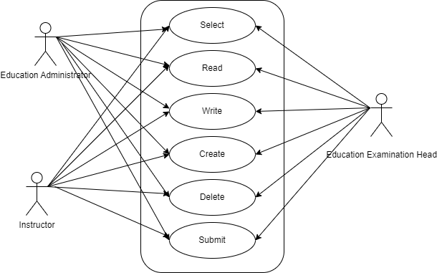
    - Form Elaboration
SL no. | Field Name | Type | Mandatory
1 | Posting Date | Date | 0
2 | Exam Assessment Plan | Link | 1
3 | Programs | Link | 0
4 | Semester | Link | 0
5 | Course | Link | 1
6 | Course Code | Data | 0
7 | Course Name | Data | 0
8 | Academic Year | Link | 1
9 | Academic Term | Link | 1
10 | Examiner | Link | 0
11 | Examiner Name | Data | 0
12 | Moderator Name | Link | 0
13 | Schedule Date | Date | 0
14 | From Time | Time | 0
15 | To Time | Time | 0
16 | Paper copy | Attach | 0

    - Screen Authorization
Sl No. | Role | Level | Select | Read | Write | Create | Delete | Submit
1 | Education Administrator | 0 | 1 | 1 | 1 | 1 | 1 | 1
2 | Education Examination Head | 0 | 1 | 1 | 1 | 1 | 1 | 1
3 | Instructor | 0 | 1 | 1 | 1 | 1 | 1 | 1

    - Component And Module
Module Related:- Education

    - Business Logic
- Go to the Exam Paper Setting list and click on New.
- Select and Add Exam Evaluation Plan, Academic year, Academic Term.
- Select and add Course
- Select the Examiner from the dropdown menu and then the Moderator Name.
- Select the Schedule Date: Select “From Time” & “To time”.
- Select and attach the Paper Copy.
- Save and Submit

    - Path of the screen
Home > Examination > Examination > Exam Paper Setting
  - Exam Block List
    - Overview
The Exam Block List displays the list of students that are blocked from applying for a particular Exam Declaration as they are not being able to clear the eligibility exam criteria.
    - Description of Problem
Create a page containing all Information about which student not eligible for exam.
    - Dependency
- Program Grades
- Programs
- Exam Declaration
- Semester
- Students
    - Table of Contents
Main Table:- TabStudent Exam Block List
Child Table:- Student Block Item
    - Use Case
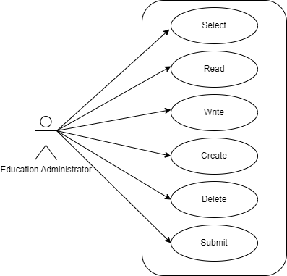
    - Form Elaboration
SL no. | Fields Name | Type | Mandatory
1 | Program Grade | Link | 1
2 | Program of Exam | Link | 1
3 | Exam Declaration | Link | 1
4 | Semester | Link | 1
5 | Send Notification | Check | 0
6 | Student Block Item | Table | 1

    - Screen Authorization
Sl No. | Role | Level | Select | Read | Write | Create | Delete | Submit
1 | Education Administrator | 0 | 1 | 1 | 1 | 1 | 1 | 1

    - Component And Module
Module Related:- Education

    - Business Logic
- Add Student Exam Block List: Select and add Program of Exam
- Select and add Exam Declaration
- Semester is auto fetched
- Select and add row in Student Block Item:
  - Enter Student ID
  - Student Name is auto fetched
  - Select and add criteria
- Save and Submit
    - Path of the screen
Home > Examination > Examination > Exam Block List
  - Student Admit Card
    - Overview
The Admit Card process is used to download the admit card after exam application has been applied for the particular exam declaration.
    - Description of Problem
Create a page containing all Information for issuing Admit card to Student.
    - Dependency
Before creating an Admit Card, it is advisable to first create the following:
- Program Enrollment
- Academic Term
- Course
- Exam Application
    - Table of Contents
Main Table:- tabStudent Admit Card
Child Table:- tabAdmit Card Course
    - Use Case Diagram
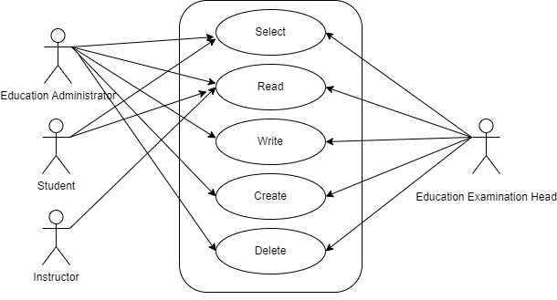
    - Form Elaboration
Sl No. | Field Name | Type | Mandatory
1 | Enrollment No. | Link | 1
2 | Student Roll No | Link | 1
3 | Student Name | Data | 1
4 | Roll No | Data | 0
5 | Current Program | Link | 1
6 | Permanant Registration Number | Data | 0
7 | Photo | Attach | 0
8 | Academic Year | Data | 0
9 | Academic Term | Link | 1
10 | Courses Offered | Section Break | 0
11 | Courses | Table | 0
12 | Signature of Principal | Signature | 0
13 | Examiner Signature | Signature | 0
14 | Signature | Attach Image | 0

    - Screen Authorization
Sl No. | Role | Level | Select | Read | Write | Create | Delete | Submit
1 | Education Administrator | 0 | 1 | 1 | 1 | 1 | 1 | 0
2 | Education Examination Head | 0 | 1 | 1 | 1 | 1 | 1 | 0
3 | Instructor | 0 | 0 | 1 | 0 | 0 | 0 | 0
4 | Student | 0 | 1 | 1 | 0 | 0 | 0 | 0

6.9.8 Component And Module
Module Related:- Education

6.9.9 Business Logic
- Go to the Student Admit Card list and click on New.
- Select and Add Registration No
- All other fields are auto fetched accordingly
- Save

6.9.10 Path of the screen
Home > Examination > Examination > Student Admit Card
  - Post Exam Declaration
    - Overview
There are some processes that needs to be available to the students and institutes,post examination and before result declaration in order to have a fair chance given to students so that they can have their doubts cleared about the marks they secure and the results that are published.
    - Description of Problem
The post exam declaration consists of 2 declarations that are mostly made open for students to apply:
- Photocopy Application
- Re-evaluation Application.
    - Dependency
Exam Declaration
    - A Table of Contents
- Main Table name :- TabPost Exam Declaration
- Child Table name :- TabExam Declaration Fee Item
    - Use Case Diagram
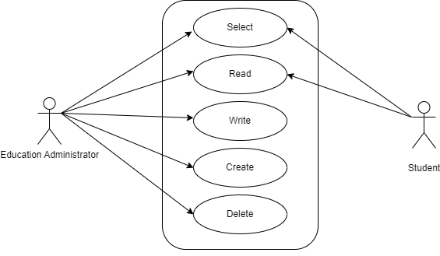
    - Form Elaboration
Sl No. | Fields | Type | Mandatory
1 | Posting Date | Date | 0
2 | Start Date | Date | 1
3 | End Date | Date | 1
4 | Exam Declaration | Link | 1
5 | Exam Name | Data | 0
6 | Fees Applicable | Select | 1
7 | Fee Structure | Table | 0

    - Screen Authorization
Sl No. | Role | Level | Select | Read | Write | Create | Delete | Submit
1 | Education Administrator | 0 | 1 | 1 | 1 | 1 | 1 | 0
2 | Student | 0 | 1 | 1 | 0 | 0 | 0 | 0

    - Component And Module
Module Related:- Education

    - Business Logic

- Select and Post Exam Declaration
- Select and add Start Date
- Select and add End Date
- Select and add Exam Declaration for which Post Exam Declaration is being issued.
- Select if Fees Applicable.
  - Select and add Fee Structure.
- Save

    - Path of the screen
Home > Examination > Examination > Post Exam Declaration

6.11 Photocopy Application

6.11.1 Overview
After a post-exam declaration, if the student wants to view his exam answer sheet, then they apply to photocopy application. The exam section attaches the copy of the student’s scanned answer sheet which is accessible from the student ID.

6.11.2 Description of Problem
Through this process, the student can raise any issues regarding his evaluation of the answer sheet by the faculty/instructor.

6.11.3 Dependency
Dependent on following Doctypes:
- Student
- Exam Declarartion
- Post Exam Declaration

6.11.4 A Table of Contents
- Main Table name :- TabPhotocopy Application
- Child Table name :- TabPhotocopy Item

6.11.5 Use Case Diagram
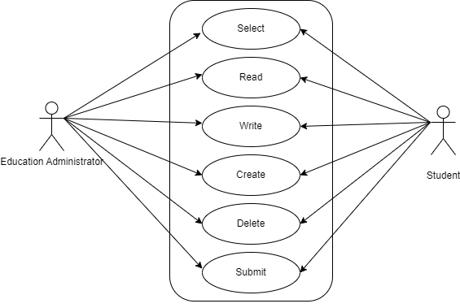

6.11.6 Form Elaboration
Sl No. | Fields | Type | Mandatory
1 | Posting Date | Date | 0
2 | Start Date | Date | 1
3 | End Date | Date | 1
4 | Exam Declaration | Link | 1
5 | Exam Name | Data | 0
6 | Fees Applicable | Select | 1
7 | Fee Structure | Table | 0

6.11.7 Screen Authorization
Sl No. | Role | Level | Select | Read | Write | Create | Delete | Submit
1 | Education Administrator | 0 | 1 | 1 | 1 | 1 | 1 | 1
2 | Student | 0 | 1 | 1 | 1 | 1 | 1 | 1

6.11.8 Component And Module
Module Related:- Education

6.11.9 Business Logic

6.11.10 Path of the screen
Home > Examination > Examination > Photocopy Application

6.12. Exam Evaluation Plan

6.12.1 Overview
An Exam Evaluation Plan is a schedule to conduct the examination/assessment of a particular course for a group of students studying that course in an on-going academic term.

6.12.2 Description of Problem
Create a form to containing all Information about a Examination like Exam Assessment Plan Item, Paper Setter List and Moderator List.

6.12.3 Dependency
- Exam Declaration
- Grading Scale
- Assessment Criteria
- Academic Year
- Academic Term
- Course

6.12.4 Table of Contents
- Main Table name :- TabExam Evaluation Plan
- Child Table name :-
- TabCourse Assessment Plan Item
- TabPapper Settwe Item
- Tabmoderator List

6.12.5 Use Case Diagram
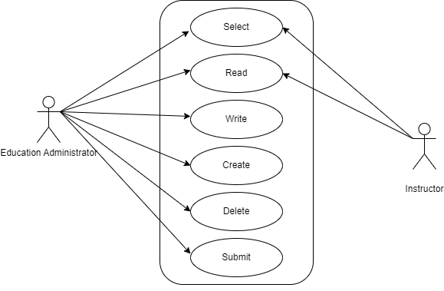

6.12.6 Form Elaboration
Sl No. | Field Name | Type | Mandatory
1 | Exam Declaration | Link | 1
2 | Grading Scale | Link | 1
3 | Assessment Criteria | Link | 1
4 | Programs | Link | 1
5 | Semester | Link | 1
6 | Academic Year | Link | 1
7 | Academic Term | Link | 1
8 | Exam Assessment Plan Item | Table | 1
9 | Paper Setting Start Date | Date | 1
10 | Paper Setting End Date | Date | 1
11 | Paper Setter List | Table
12 | Moderator List | Table

6.12.7 Screen Authorization
Sl No. | Role | Level | Select | Read | Write | Create | Delete | Submit
1 | Education Administrator | 0 | 1 | 1 | 1 | 1 | 1 | 1
2 | Instructor | 0 | 1 | 1 | 0 | 0 | 0 | 0

6.12.8 Component And Module
Module Related:- Education

6.12.9 Business Logic

6.12.10 Path of the screen
Home > Examination > Evaluation > Exam Evaluation Plan

6.13. Criteria Wise Evaluation

6.13.1 Overview
Criteria-wise Evaluation allows us to create an evaluation for a particular assessment criterion in a course for a student enrolled in that course.

6.13.2 Description of Problem
Create a form to containing all Information about a Evaluation Criteria like Student details, Earned marks, Total Marks and etc.

6.13.3 Dependency
- Student
- Exam Declaration
- Assessment Criteria
- Academic Year
- Academic Term
- Course

6.13.4 Table of Contents
- Main Table name :- TabCriteria Wise Evaluation

6.13.5 Use Case Diagram
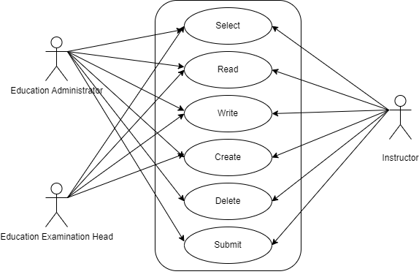

6.13.6 Form Elaboration
Sl No. | Field Name | Type | Mandatory
1 | Student | Link | 1
2 | Student Name | Data
3 | Roll No | Data
4 | Registration Number | Data
5 | Academic Year | Link | 1
6 | Academic Term | Link | 1
7 | Course | Link | 1
8 | Course Name | Data
9 | Assessment Criteria | Link | 1
10 | Exam Declaration | Link
11 | Program Grade | Link
12 | Programs | Link
13 | Semester | Link
14 | Exam Assessment Plan | Link
15 | Earned Marks | Float
16 | Total Marks | Float

6.13.7 Screen Authorization
Sl No. | Role | Level | Select | Read | Write | Create | Delete | Submit
1 | Education Administrator | 0 | 1 | 1 | 1 | 1 | 1 | 1
2 | Instructor | 0 | 1 | 1 | 1 | 1 | 1 | 1
3 | Education Examination Head | 0 | 1 | 1 | 1 | 1 | 0 | 0

6.13.8 Component And Module
Module Related:- Education

6.13.9 Business Logic
- Select and add Criteria Wise Evaluation.
- User will select and enter the Student Name
- User will select and enter Academic Year and Academic Term
- User will select the Course from the drop-down list.
- User will select and add Assessment Criteria.
- User will select and add Exam Declaration and Exam Evaluation Plan if any.
- User will click Save button.

6.13.10 Path of the screen
Home > Examination > Evaluation > Criteria Wise Evaluation

6.14. Continuous Evaluation

6.14.1 Overview
Continuous Evaluation is used to assess the Assessment Criteria done for a course for an
individual student.

6.14.2 Description of Problem
Create a form to containing all Information about a Assessment Criteria like Earned marks, Grace Marks, Total Marks, and etc.

6.14.3 Dependency
- Student
- Assessment Criteria
- Academic Year
- Academic Term
- Course

6.14.4 Table of Contents
- Main Table name :- TabContinuous Evaluation
- Child Table Name:- TabFinal Credit item

6.14.5 Use Case Diagram
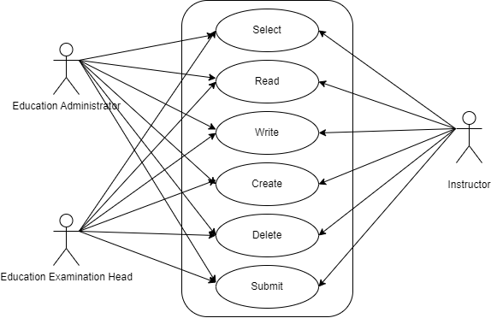

6.14.6 Form Elaboration
Sl No. | Field Name | Type | Mandatory
1 | Student | Link | 1
2 | Student Name | Data
3 | Course | Link | 1
4 | Roll No | Data
5 | Registration Number | Data
6 | Course Code | Data
7 | Course Name | Data
8 | Assessment Criteria | Link | 1
9 | Academic Year | Link | 1
10 | Academic Term | Link | 1
11 | Get Assessments | Button
12 | Final Credit Item | Table | 1
13 | Grace Marks | Float
14 | Earned Credits | Float
15 | Total Credits | Float
16 | Weightage Marks | Float
17 | Final Marks | Float | 1
18 | Out of Marks | Float

6.14.7 Screen Authorization
Sl No. | Role | Level | Select | Read | Write | Create | Delete | Submit
1 | Education Administrator | 0 | 1 | 1 | 1 | 1 | 1 | 1
2 | Instructor | 0 | 1 | 1 | 1 | 1 | 1 | 1
3 | Education Examination Head | 0 | 1 | 1 | 1 | 1 | 1 | 1

6.14.8 Component And Module
Module Related:- Education

6.14.9 Business Logic
- Select and add Continuous Evaluation.
2. User will select and enter the Student Name
3. User will select the Course from the drop down list.
4. User will select and add Assessment Criteria.
5. User will select Get Assessments.
6. The Assessment Criteria for that particular course is auto fetched.
7. User will enter Grace Marks if required.
8. User will Earned Credits and Weightage Marks is auto fetched.
9. User will enter the Final Marks after any revision.
10. User will click Save button.

6.14.10 Path of the screen
Home > Examination > Evaluation > Continuous Evaluation

6.15. Final Exam Result

6.15.1 Overview
Final Exam Result is used to evaluate the final assessment of a student for a particular semester.

6.15.2 Description of Problem
Create a form to containing all Information about a Final assessment of a student like Assessment Result.

6.15.3 Dependency
- Student
- Grading Scale

6.15.4 Table of Contents
- Main Table name :- TabFinal Exam Result
- Child Table name :-
- TabAssessment Result Item
- TabEvaluation Result Item
- TabPrevious Semester SGPA

6.15.5 Use Case Diagram
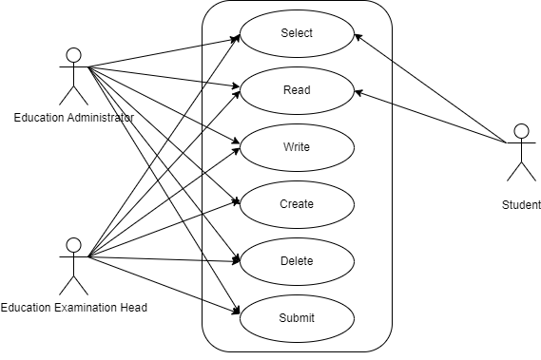

6.15.6 Form Elaboration
Sl No. | Field Name | Type | Mandatory
1 | Programs | Link
2 | Semester | Link
3 | Course | Link
4 | Academic Year | Link
5 | Academic Term | Link
6 | Status | Select
7 | Student | Link | 1
8 | Student Name | Data
9 | Roll No | Data
10 | Registration Number | Data
11 | Student Group | Link
12 | Assessment Group | Link
13 | Grading Scale | Link | 1
14 | Assessment Status | Data
15 | Result | Section Break
16 | Get Result | Button
17 | Assessment Result Item | Table
18 | Evaluation Result Item | Table
19 | SGPA | Float
20 | Result | Data
21 | Overall CGPA | Float
22 | Summary | Section Break
23 | Comment | Small Text
24 | Credit Point | Float
25 | SGPA in to Credit Point | Data

6.15.7 Screen Authorization
Sl No. | Role | Level | Select | Read | Write | Create | Delete | Submit
1 | Education Administrator | 0 | 1 | 1 | 1 | 1 | 1 | 1
2 | Student | 0 | 1 | 1 | 0 | 0 | 0 | 0
3 | Education Examination head | 0 | 1 | 1 | 1 | 1 | 1 | 1

6.15.8 Component And Module
Module Related:- Education

6.15.9 Business Logic
- Select and add Final Exam Result.
2. User will Select and enter the Student Name
3. All the information required is auto fetched.
4. User will select and add Grading Scale.
5. User will click on Get Result button.
6. The Assessment Result items for that particular student is auto fetched.
7. The Evaluation Result item is also auto fetched and calculated on the basis of grading
scale.
- The SGPA, Result and Grade is also calculated and automatically fetched.
- User will Submit and Save the Final Exam Result.
- The final exam result is declared for a particular student.

6.15.10 Path of the screen
Home > Examination > Evaluation > Final Exam Result

6.16 Criteria Wise Evaluation Tool

6.16.1 Overview
Criteria Wise Evaluation Tool helps in entering marks earned by the students in a semester for a particular course and particular assessment criteria.

6.16.2 Description of Problem
Create a form to containing all Information about a Evaluation Criteria like Student details, Earned marks, Total Marks and etc.

6.16.3 Dependency
- Student
- Exam Declaration
- Assessment Criteria
- Academic Year
- Academic Term
- Course

6.16.4 Table of Contents
Main Table name :- TabCriteria Wise Evaluation

6.16.5 Use Case Diagram
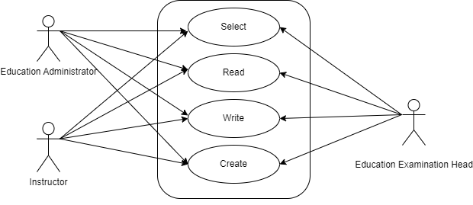

6.16.6 Form Elaboration
Sl No. | Field Name | Type | Mandatory
1 | Academic Year | Link Field | 1
2 | Academic Term | Link Field | 1
3 | Exam Declaration | Link Field
4 | Exam Assessment Plan | Link Field
5 | Total Students | Int Field
6 | Program Grade | Link Field | 1
7 | Programs | Link Field | 1
8 | Semester | Link Field | 1
9 | Course | Link Field | 1
10 | Course Code | Text Field
11 | Course Name | Text Field
12 | Assessment Criteria | Link Field | 1
13 | Student Details Data | Table

6.16.7 Screen Authorization
Sl No. | Role | Level | Select | Read | Write | Create | Delete | Submit
1 | Education Administrator | 0 | 1 | 1 | 1 | 1 | 0 | 0
2 | Instructor | 0 | 1 | 1 | 1 | 1 | 0 | 0
3 | Education Examination head | 0 | 1 | 1 | 1 | 1 | 0 | 0

6.16.8 Component And Module
Module Related:- Education

6.16.9 Business Logic
1. Go to Criteria Wise Evaluation Tool.
2. Select and add Academic Year, Academic Term.
3. Select and add Programs, Semesters.
4. Select and add Course for which assessment criteria is to be evaluated.
5. Select and add Assessment Criteria.
6. If the Assessment Criteria is linked to any exams, then:
- User will Select and add Exam Declaration from the drop down list.
- User will Select and add Exam Evaluation Plan from the drop down list.
7.The total number of Students along with the Student list is fetched.
8. Select and enter the marks for each student in the Earned Marks field.
9. Click Save button.
The entries for all the Students’ Criteria Wise Evaluation is created in the Criteria Wise
Evaluation Document which can be verified and finally submitted.

6.16.10 Path of the screen
Home > Examination > Tools > Criteria Wise Evaluation Tool

6.17 Continuous Evaluation Tool

6.17.1 Overview
Continuous Evaluation Tool is used for view student marks and also we able to give grace marks.

6.17.2 Description of Problem
Create a form to containing all Information about student marks.

6.17.3 Dependency
- Program Grade
- Assessment Criteria
- Academic Year
- Academic Term
- Course
- Programs
- Semester

6.17.4 Table of Contents
Main Table name :- TabContinuous Evaluation

6.17.5 Use Case Diagram
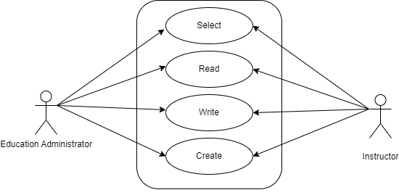

6.17.6 Form Elaboration
Sl No. | Field Name | Type | Mandatory
1 | Academic Year | Link | 1
2 | Academic Term | Link | 1
3 | Program grade | Link | 1
4 | Programs | Link | 1
5 | Semester | Link | 1
6 | Course | Link | 1
7 | Course Name | Data
8 | Course Code | Data
9 | Assessment Criteria | Link | 1

6.17.7 Screen Authorization
Sl No. | Role | Level | Select | Read | Write | Create | Delete | Submit
1 | Education Administrator | 0 | 1 | 1 | 1 | 1 | 0 | 0
2 | Instructor | 0 | 1 | 1 | 1 | 1 | 0 | 0

6.17.8 Component And Module
Module Related:- Education

6.17.9 Business Logic
- Select and add Continuous Evaluation Tool.
- Select Academic Year, Academic Term, Program Grade, Programs, Semester, Course, Assessment Criteria.
- Then One HTML Table fetch where you can see Student Marks Details.
- In HTML Table you can able to give Grace Marks.
- Click on Submit

6.17.10 Path of the screen
Home > Examination > Tool> Continuous Evaluation Tool

6.18 Final Result Declaration

6.18.1 Overview
Final Result Declaration Tool is used to declare the final exam results for a particular group/batch of students in a semester.

6.18.2 Description of Problem
Create a form to containing all Information about student Completion Status.

6.18.3 Dependency
- Program Grade
- Program
- Academic Year
- Academic Term
- Semester
- Grading Scale

6.18.4 Table of Contents
Main Table name :- TabFinal Result Declarartion

6.18.5 Use Case Diagram
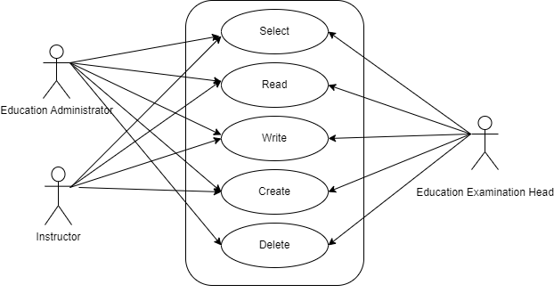

6.18.6 Form Elaboration
Sl No. | Field Name | Type | Mandatory
1 | Program Grade | Link | 1
2 | Programs | Link | 1
3 | Semester | Link | 1
4 | Grading scale | Link | 1
5 | Academic Year | Link | 1
6 | Academic Term | Link | 1
7 | Result Creation Status | Select
8 | Get Students | Button
9 | Total Enrolled Student | Int
10 | Result Declaration Student | Table

6.18.7 Screen Authorization
Sl No. | Role | Level | Select | Read | Write | Create | Delete | Submit
1 | Education Administrator | 0 | 1 | 1 | 1 | 1 | 1 | 0
2 | Instructor | 0 | 1 | 1 | 1 | 1 | 0 | 0
3 | Education Examination Head | 0 | 1 | 1 | 1 | 1 | 1 | 0

6.18.8 Component And Module
Module Related:- Education

6.18.9 Business Logic
1. Go to Final Result Declaration Tool; Add Final Result Declaration
2. Select and add Programs.
3. Select and add Semester.
4. Select and add Grading Scale.
5. Select and add Academic Year, Academic Term.
6. Click“Get Students”.
7. Total Enrolled Students is shown in the field.
8. The Result Declaration Student List is auto fetched along with Completion
Status/Pending Status.
9. Click Save button.
10. The draft entries from the Final Result Declaration Tool is created in Final Exam Result.
11. The draft entries are now then verified and submitted.

6.18.10 Path of the screen
Home > Examination > Tool> Final Result Declaration Tool

6.19 Cumulative Marksheet Tool

6.19.1 Overview
Cumulative Marksheet Tool help to complies all the marks obtain by a student throughout all the semester.

6.19.2 Description of Problem
Create a form to containing all Information about Student Marksheet throughout all the semester.

6.19.3 Dependency
- Programs
- Academic Term
- Student

6.19.4 Table of Contents
Main Table name :- TabCumulative Marksheet
Child Table Name:- TabMarksheet

6.19.5 Use Case Diagram
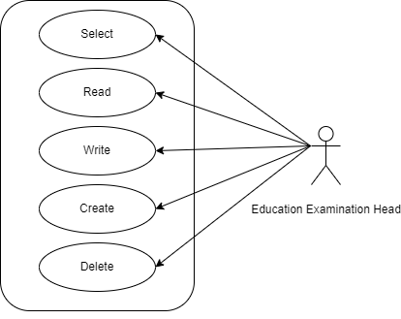

6.19.6 Form Elaboration
Sl No. | Field Name | Type | Mandatory
1 | BRANCH | Data
2 | School of | Data
3 | Specialization | Data
4 | Programs | Link | 1
5 | Current Academic Term | Link | 1
6 | Year of Admission | Link
7 | Year of Admission | Data
8 | Completed On | Data
9 | Year of Completion | Link
10 | Result Creation Status | Select
11 | Get Students | Button
12 | Total Students for Marksheet | Int
13 | Cumulative Marksheet Student | Table
14 | Signature of Examiner | Attach Image

6.19.7 Screen Authorization
Sl No. | Role | Level | Select | Read | Write | Create | Delete | Submit
1 | Education Examination Head | 0 | 1 | 1 | 1 | 1 | 1 | 0

6.19.8 Component And Module
Module Related:- Education

6.19.9 Business Logic
- Go to Add Cumulative Marksheet Tool.
- Select Program, Academic Term etc.
- Click on Get Student Button
- Throug that button all the student going to fetch in child table.
- Add Signature of Examiner
- Click on Save

6.19.10 Path of the screen
Home > Examination > Tool> Cumulative Marksheet Tool

6.20 Provisional Certificate Tool

6.20.1 Overview
Provisional Certificate is a temporary document provided by a university until a permanent degree is issued and imparted on convocation.

6.20.2 Description of Problem
Create a form to containing all Information about student detail for provisional certificate.

6.20.3 Dependency
- Programs
- Academic Term
- Student

6.20.4 Table of Contents
Main Table name :- TabProvisional Certificate Tool
Child Table Name:- TabMarksheet

6.20.5 Use Case Diagram

6.20.6 Form Elaboration
Sl No. | Field Name | Type | Mandatory
1 | Programs | Link | 1
2 | Current Academic Term | Link | 1
3 | Place | Data
4 | Name of Degree | Data
5 | Certificate Creation Status | Select
6 | Get Students | Button
7 | Total Students for Certificate | Int
8 | Provisional Certificate Student | Table

6.20.7 Screen Authorization
Sl No. | Role | Level | Select | Read | Write | Create | Delete | Submit
1 | Education Administrator | 0 | 1 | 1 | 1 | 1 | 1 | 0

6.20.8 Component And Module
Module Related:- Education

6.20.9 Business Logic
- Go to Add Provisional Certificate Tool.
- Select Program, Academic Term etc.
- Click on Get Student Button
- Throug that button all the student going to fetch in child table.
- Click on Save

6.20.10 Path of the screen
Home > Examination > Tool> Provisional Certificate Tool

6.21 Migration Certificate Tool

6.21.1 Overview
Migration Certification is a document issued by the concerned University or Board in which one studies.

6.21.2 Description of Problem
Migration Certification tool help to create migration in bulk.

6.21.3 Dependency
- Programs
- Academic Term
- Student

6.21.4 Use Case Diagram
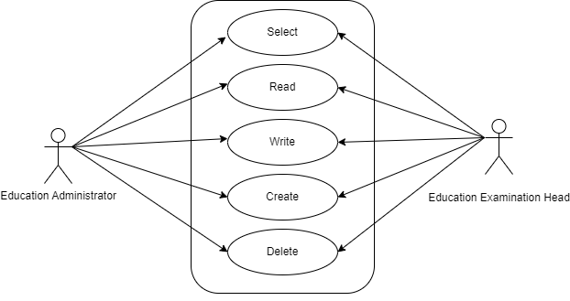

6.21.5 Table of Contents
Main Table Name:- Migration Certification Tool
Child Table Name:- Marksheet

6.21.6 Form Elaboration
Sl No. | Field Name | Type | Mandatory
1 | Programs | Link | 1
2 | Current Academic Term | Link | 1
3 | Academic Year | Link
4 | Academic Session | Data | 1
5 | Resistrar Signature | Attach Image
6 | Certificate Creation Status | Select
7 | Get Students | Button
8 | Total Students for Certificate | Int
9 | Migration Certificate Student | Table

6.21.7 Screen Authorization
Sl No. | Role | Level | Select | Read | Write | Create | Delete | Submit
1 | Education Administrator | 0 | 1 | 1 | 1 | 1 | 1 | 0
2 | Education Examination Head | 0 | 1 | 1 | 1 | 1 | 1 | 0

6.21.8 Components And Modules
Module Related:- Education

6.21.9 Business Logic
- User will go to Migration Certificate; Add Migration Certificate.
- User will select and enter Student Name
- The related details of the Student are auto fetched.
- User will Select and add Place.
- User will select and add Name of Degree.
- User will click Save button.
- User will select the Print icon.
- Change the standard form to Migration Certificate.

6.21.10 Path of the screen
Home > Examination > Tools > Migration Certificate Tool

6.22 Conduct Certificate Tool

6.22.1 Overview
A Conduct Certificate specifies the behavior of an individual during a period of time, in an official place. It is also sometimes referred to as a character certificate

6.22.2 Description of Problem
Conduct Certificate tool help to create Conduct Certificate in bulk.

6.22.3 Dependency
- Programs
- Academic Term
- Student

6.22.4 Use Case Diagram
6.21.5 Table of Contents
Main Table Name:- Conduct Certification Tool
Child Table Name:- Marksheet

6.22.6 Form Elaboration
Sl No. | Field Name | Type | Mandatory
1 | Programs | Link | 1
2 | Current Academic Term | Link | 1
3 | Academic Year | Link
4 | Academic Year Start | Date
5 | Academic Year End | Date
6 | Admission Year | Data | 1
7 | Leaving Year | Data | 1
8 | Date | Date | 1
9 | Registrar Signature | Attach Image
11 | Certificate Creation Status | Select
12 | Get Students | Button
13 | Total Students for Certificate | Int
14 | Conduct Certificate Student | Table

6.22.7 Screen Authorization
Sl No. | Role | Level | Select | Read | Write | Create | Delete | Submit
1 | Education Administrator | 0 | 1 | 1 | 1 | 1 | 1 | 0
2 | Education Examination Head | 0 | 1 | 1 | 1 | 1 | 1 | 0

6.22.8 Components And Modules
Module Related:- Education

6.22.9 Business Logic
- Go to Add Conduct Certificate Tool.
- Select Program, Academic Term etc.
- Add Registrar Signature
- Click on Get Student Button
- Throug that button all the student going to fetch in child table.
- Click on Save

6.22.10 Path of the screen
Home > Examination > Tools> Conduct Certificate Tool

6.23 Leaving Certificate

6.23.1 Overview
Leaving Certificate is issued when the students have completed their programs. In the ERP the leaving certificate is issued when their Assessment Status is complete. It is a certificate showing a person has completed his or her time at school, sometimes requiring the passing of an exam or exams.

6.23.2 Description of Problem
Create a form to containing all Information about Student detail for Leaving Certificate.

6.23.3 Dependency
- Student

6.23.4 Use Case Diagram
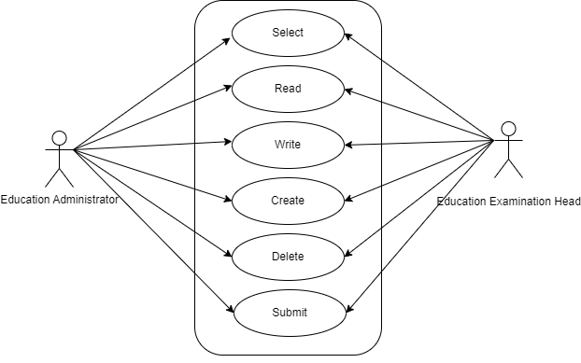
6.21.5 Table of Contents
Main Table Name:- TabLeaving Certificate

6.23.6 Form Elaboration
Sl No. | Field Name | Type | Mandatory
1 | Student | Link | 1
2 | Name of the Student : | Data
3 | Roll No | Data
4 | Mother's Name | Data
5 | Father's Name | Data
6 | Village : | Data
7 | Police Station : | Data
8 | Post Office : | Data
9 | District : | Data
11 | Pincode | Data
12 | Date of Admission | Data
13 | Date of Birth | Data
14 | Date of Leaving the School : | Data
15 | Class in which she/he was reading | Link
16 | Character | Data
17 | Whether he/she has passed the Annual Examination | Select
18 | Date | Data
19 | Registrar Signature | Attach Image

6.23.7 Screen Authorization
Sl No. | Role | Level | Select | Read | Write | Create | Delete | Submit
1 | Education Administrator | 0 | 1 | 1 | 1 | 1 | 1 | 1
2 | Education Examination Head | 0 | 1 | 1 | 1 | 1 | 1 | 1

6.23.8 Components And Modules
Module Related:- Education

6.23.9 Business Logic
1. User will go to Leaving Certificate; Add Leaving Certificate
2. User will select and enter Student Name.
3. The details related to Student is auto fetched.
4. User will select and add Character details.
5. User will select and add Annual Exam.
6. User will select and add Reason for Leaving the College.
7. User will click Save button.
8. User will select the Print icon.
9. Change the standard form to Leaving Certificate

6.23.10 Path of the screen
Home > Examination > Transcripts> Leaving Certificate

6.24 Provisional Certificate

6.24.1 Overview
Provisional Certificate is issued in order to make sure that the student is not deprived of any future opportunities in the form of a job or higher education. It helps the college administration in keeping a record of students who have passed from the university.

6.24.2 Description of Problem
Create a form to containing all Information about Student detail for Provisional Certificate.

6.24.3 Dependency
- Student
- Program

6.24.4 Use Case Diagram
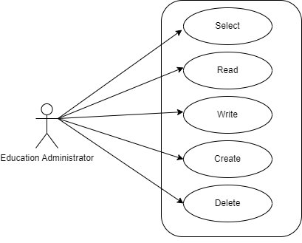
6.21.5 Table of Contents
Main Table Name:- Provisional Certificate

6.24.6 Form Elaboration
Sl No. | Field Name | Type | Mandatory
1 | Student | Link Field | 1
2 | Student Name | Text Field
3 | Roll No | Text Field
4 | Permanent Registration Number | Text Field | 1
5 | Date | Date | 1
6 | Programs | Link Field | 1
7 | Place | Text Field
8 | Name Of Degree | Text Field

6.24.7 Screen Authorization
Sl No. | Role | Level | Select | Read | Write | Create | Delete | Submit
1 | Education Administrator | 0 | 1 | 1 | 1 | 1 | 1 | 0

6.24.8 Components And Modules
Module Related:- Education

6.24.9 Business Logic
1. User will go to Leaving Certificate; Add Leaving Certificate
2. User will select and enter Student Name.
3. The details related to Student is auto fetched.
4. User will select and add Character details.
5. User will select and add Annual Exam.
6. User will select and add Reason for Leaving the College.
7. User will click Save button.
8. User will select the Print icon.
9. Change the standard form to Leaving Certificate

6.24.10 Path of the screen
Home > Examination > Transcripts > Provisional Certificate

6.25 Migration Certificate

6.25.1 Overview
Migration Certificate is a document issued by the concerned University or Board in which one studies. It helps in getting admission to another institution or any education board and it is issued at the completion of the course along with other necessary documents.

6.25.2 Description of Problem
Create a form to containing all Information about Student detail for Migration Certificate.

6.25.3 Dependency
- Student
- Academic Year

6.25.4 Use Case Diagram
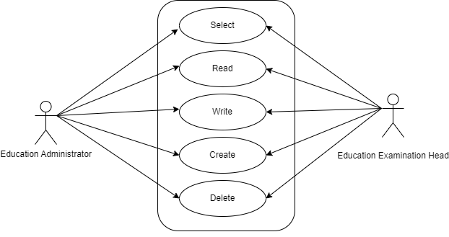
6.21.5 Table of Contents
Main Table Name:- TabMigration Certificate

6.25.6 Form Elaboration
Sl No. | Field Name | Type | Mandatory
1 | Student | Link Field | 1
2 | Student Name | Text Field
3 | Roll No | Text Field
4 | Permanent Registration Number | Text Field
5 | Programs | Link Field
6 | Academic Year | Link Field | 1
7 | Academic Session | Text Field
8 | Resistrar Signature | Attach Image

6.25.7 Screen Authorization
Sl No. | Role | Level | Select | Read | Write | Create | Delete | Submit
1 | Education Administrator | 0 | 1 | 1 | 1 | 1 | 1 | 0
2 | Education Examination Head | 0 | 1 | 1 | 1 | 1 | 1 | 0

6.25.8 Components And Modules
Module Related:- Education

6.25.9 Business Logic
1. User will go to Migration Certificate; Add Migration Certificate.
2. User will select and enter Student Name
3. The related details of the Student are auto fetched.
4. User will Select and add Place.
5. User will select and add Name of Degree.
6. User will click Save button.
7. User will select the Print icon.
8. Change the standard form to Migration Certificate.

6.25.10 Path of the screen
Home > Examination > Transcripts > Migration Certificate

6.26 Conduct Certificate

6.26.1 Overview
A Conduct Certificate specifies the behavior of an individual during a period of time, in an official place. It is also sometimes referred to as a character certificate. A conduct certificate is given to a student when he wants to get admission in another institute or in case of transfer.

6.26.2 Description of Problem
Create a form to containing all Information about Student detail for Conduct Certificate.

6.26.3 Dependency
- Student
- Academic Year

6.26.4 Use Case Diagram
6.26.5 Table of Contents
Main Table name:- TabConduct Certificate

6.26.6 Form Elaboration
Sl No. | Field Name | Type | Mandatory
1 | Student | Link Field | 1
2 | Student Name | Text Field
3 | Roll No | Text Field
4 | Programs | Link Field
5 | Academic Year | Link Field | 1
6 | Admission Year | Text Field
7 | Leaving Year | Text Field
8 | Academic Year Start | Date Picker
9 | Academic Year End | Date Picker
10 | Registrar Signature | Attach Image
11 | Date | Date | 1

6.26.7 Screen Authorization
Sl No. | Role | Level | Select | Read | Write | Create | Delete | Submit
1 | Education Administrator | 0 | 1 | 1 | 1 | 1 | 1 | 0
2 | Education Examination Head | 0 | 1 | 1 | 1 | 1 | 1 | 0

6.26.8 Components And Modules
Module Related:- Education

6.26.9 Business Logic
- User will go to Conduct Certificate; Add Conduct Certificate.
- User will select and enter Student Name.
- The related details of the Student are auto fetched.
4. User will select and add Place.
5. User will add name of degree.
6. User will click Save button.
7. User will select the Print icon.
8. Change the standard form to Conduct Certificate.

6.26.10 Path of the screen
Home > Examination > Transcripts > Conduct Certificate

6.27 Cumulative Marksheet

6.27.1 Overview
Cumulative Marksheet is a compilation of all the semesters with their grades in a single certificate. The Cumulative marksheet will have a list of subjects, grades obtained and CGPA (Cumulative Grade Point Average). And also details of students, such as roll number, name, age and date of birth, program enrollment.

6.27.2 Description of Problem
Create a form to containing all Information about Student detail for Cumulative Marksheet.

6.27.3 Dependency
No Dependency

6.27.4 Use Case Diagram
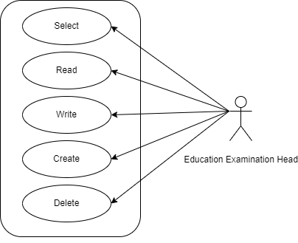
6.27.5 Table of Contents
Main Table Name:- TabCumulative Marksheet
Child Table Name:-
- TabCummulative Courses Item
- TabCumulatice Grades Item

6.27.6 Form Elaboration
Sl No. | Field Name | Type | Mandatory
1 | Student | Link
2 | Student Name | Data
3 | Roll No | Data
4 | BRANCH | Data
5 | Registration Number | Data
6 | COMPLETED ON | Data
7 | Year of Admission | Link
8 | Year of Completion | Link
9 | PROGRAMME | Link
10 | School of | Data
11 | SPECIALIZATION | Data
12 | Year of Admission | Data
13 | Cumulative Courses Item | Table
14 | Cumulative Grades Item | Table
15 | Result | Section Break
16 | CGPA | Float
17 | RESULT | Data
18 | Signature of Examiner | Attach Image

6.27.7 Screen Authorization
Sl No. | Role | Level | Select | Read | Write | Create | Delete | Submit
1 | Education Examination Head | 0 | 1 | 1 | 1 | 1 | 1 | 0

6.27.8 Components And Modules
Module Related:- Education

6.27.9 Business Logic
- User will go to Cumulative Marksheet; Add Cumulative Marksheet.
- User will select and enter Student Name.
- The related details of the Student are auto fetched.
- User will click Save button.
- User will select the Print icon.
- Change the standard form to Cumulative Marksheet.
- Print the Cumulative Marksheet.

6.27.10 Path of the screen
Home > Examination > Transcripts > Cumulative Marksheet

